Social Support Services  For public assistance benefits like SNAP, Medicaid, or KTAP for cash assistance call  1-855-306-8959 or visit benefind.ky.gov.  Emergency Needs  Name: description of services  Open from day-day, from #AM-#PM  Address  Website…………………….. phone number  Name: description of services  Open from day-day, from #AM-#PM  Address  Website…………………….. phone number  Name: description of services  Website…………………….. phone number  Name: description of services  phone number  Food Assistance  Name: description of services  Open from day-day, from #AM-#PM  Address  Website………………………. phone number  Name: description of services  Open from day-day, from #AM-#PM  Address  Website………………………. phone number  Note: Not all resources will have a website, phone number, address, etc. Some sections may have more resources than others. This template can be modified to suit the needs of each community. Some information can be left out in order to include more resources. For additional guidance,  please refer to the Resource Guide manual. |  | Health Services  Call 1-855-459-6328 to apply for Medicaid or visit HealthBenefitExchange.ky.gov for help.  Emergency Dept. and Hospitals  Name  address  phone number | Website  Health Centers and Rural Clinics  Name  address  phone number | Website  Name  address  phone number | Website  Name  address  phone number | Website  Housing  Name  description day-day from #PM-#AM.................................. phone number  Name  description...……………… phone number  Legal Services  Name  Description  Website…………………… phone number  Name  Description  Website………….….…….. phone number  Name  Description  Website | Place Holder for Image  COUNTY NAME RESOURCE Guide  - This guide contains a short list of the resources available in and around County Name.  - The information provided is subject to change.  Insert logos here if desired or delete this box  - Updated 0#-0#-2024 Version 00#
Harm Reduction/Syringe Program  Health department name  address............ phone number  Open DAYS from TIMES  Services: insert text  Behavioral Health Center  name….............…........ phone number  address  Open on day-day, from #AM-#PM  name….............…........ phone number  address  Open on day-day, from #AM-#PM  Support and Treatment Locators  National Hotlines  Substance Abuse Mental Health Services Administration (SAMHSA)  Treatment locator............… 1-800-662-4357  Online at findtreatment.gov  National Suicide Prevention Lifeline  24/7 support for people in crisis and/or distress................................ 1-800-273-8255  Online at suicidepreventionlifeline.org  Never Use Alone  Overdose prevention when using drugs alone  neverusealone.com.............. 1-877-  Kentucky Support and Treatment Locators  FindHelpNowKY  Online treatment locator at FindHelpNowKY.org  KY Help Call Center  Call Mon-Fri from 8:30AM-5:30PM to speak with a referral specialist...... 1-877-859-4357  Online at hopeandhelpky.com  Voices of Hope Information and Support Line.................................... 1-888-Hope4KY | Naloxone (Narcan)  Call 911 in an emergency.  Visit odcp.ky.gov/stop-overdoses for more.  Pharmacy Name  Available for purchase............… phone number  address  Open day-day #AM-#PM, day #AM-#PM  Pharmacy Name  Available for purchase.............… phone number  address  Open day-day #AM-#PM, day #AM-#PM, and day #AM-#PM  Pharmacy Name  Available for purchase............… phone number  Street Address  Open day-day from #AM-#PM  Online Resource Name  Available for free/by mail.........… phone number  Description  Website  Domestic Violence Resources  Name: description of services  website……........................… phone number  Name: description of services............…...............…. phone number  Transportation  name: description of services  website…….............……….….. phone number  name: description of services  website………..…….….............. phone number  name: description of services  description……...........…………. phone number |  |  | Meetings  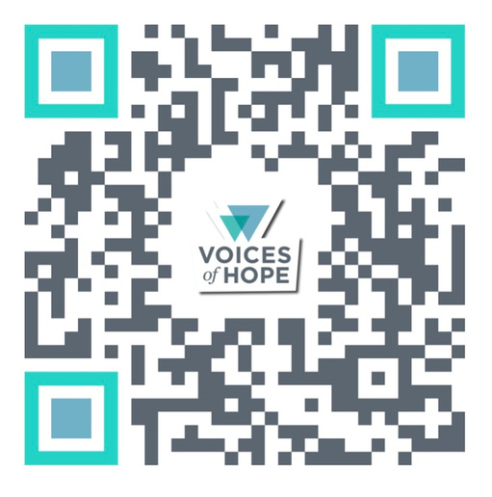  Self-Management and Recovery Training (SMART) Recovery: Medication-friendly recovery meetings. Scan the QR code, visit linktr.ee/recoveryonline , or call 1-888-Hope4KY. SMART Recovery Friends & Family meetings may be available.  Medication-Assisted Recovery Anonymous (MARA): Information about in-person meetings across Kentucky and online meetings is at  mara-international.org/Kentucky.  Medication for Opioid Use Disorder  Locations in CITY NAME:  name...............................… phone number  Medications: <medication names>  Address  name.................................. phone number  Medications: <medication names>  Address  name  website….......... phone number  Medications: <medication names>  Address  name...…...…...........……… phone number  Medications: <medication names>  Address  name...………...........….. phone number  Medications: <medication names>  Address  name……..........................…. phone number  Medications: Buprenorphine, Sublocade  Address  name.......…........... phone number  Medications: <medication names>

